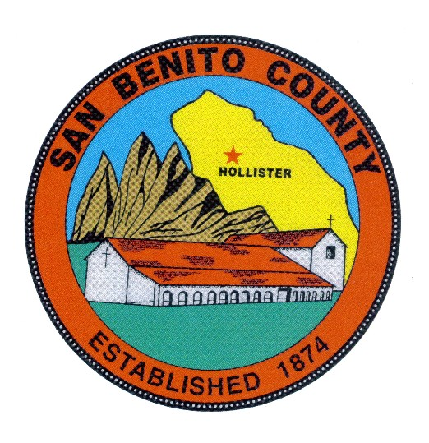
COUNTY OF SAN BENITO, STATE OF CALIFORNIA

BEHAVIORAL HEALTH BOARD

1131 SAN FELIPE ROAD

HOLLISTER, CA 95023

PHONE (831) 636-4020

A G E N D A
Behavioral Health Board Meeting
Date: Thursday, May 16, 2019

Time: 12:00 p.m. to 1:30 p.m.

Place: Behavioral Health Conference Room, 1131 San Felipe Rd.
Hollister, CA 95023

Members: Rosa Apodaca, Pat Loe, Sherry Holmquist, Dan Sanidad, Margie Barrios, BOS Appointee, Board of Supervisor appointee Peter Hernandez, Tina Garza

════════════════════════════════════════════════════

- CALL MEETING TO ORDER

- INTRODUCTIONS

- ROLL CALL

- CERTIFICATE OF POSTING

- MINUTES – ACTION: Review and approve the Behavioral Health Board meeting minutes of the April 18, and March 21, 2019 meeting.

- PUBLIC COMMENT:

- CORRESPONDENCE:
  - Articles available at the meeting for review and copies available on request.

- OLD BUSINESS:

- CHAIRPERSON REPORT

- BHB Member Trainings Attended

- Esperanza Updates by Maria Sanchez, Case Management Services Manager
and Sherry Holmquist,
May is Mental Health Month Updates

12) DIRECTOR’S REPORT

  - Standing Item for discussion- Updates on the MHSA Capital Facilities/Tech Component and the proposed new Behavioral Health Department Building.

  - State/County Budget Updates, other relevant Behavioral Health budget issues and also Legislative actions and trailer bills with budget implications.

  - Update on the MHSA Funded Bond, “No Place Like Home”

  - Updates, Standing Agenda Item, Other MHSA issues, Innovation Proposed Project Updates (Mentally Ill Deferral and Reentry Court)

  - Discuss status of Drug Medical Organized Delivery System Waiver Project

  - Discuss State Plan Drug MediCal Onsite Program Review by DHCS (Dept. of Health Care Services)

15) Quality Improvement updates by QI Managers, Events/Issues Report
  - Trainings upcoming and other new issues
  - Cultural Competency Committee Information

16) Updates on Substance Abuse Program Activities by Steve Reid Program Manager
  - Updates on the Drug MediCal Waiver Implementation

17) Recruitment/Personnel Updates; MH Clinicians (Ongoing)
New Case Managers (One New Hire, ongoing for 1 more FTE’s) MH Nurse- Offer Made and Accepted, SUDS Counselors, 2 FTE’s recruitment in progress

ADJOURNMENT
To confirm meeting dates and time contact SBCBH (831) 636-4020.
Dates for future meetings are generally scheduled for the (3rd) third Thursday of every month at 12:00 p.m. to 1:30 p.m. No meeting is scheduled for the month of August and the November and December meetings are combined as a holiday potluck luncheon meeting scheduled in December. To confirm meeting dates and times contact SBCBH (831) 636-4020.

ANY MEETING DATE MAY BE SUBJECT TO CHANGE UPON BEHAVIORAL HEALTH BOARD APPROVAL.

