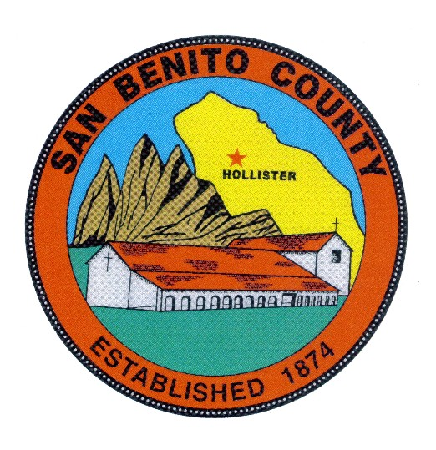
COUNTY OF SAN BENITO, STATE OF CALIFORNIA

BEHAVIORAL HEALTH BOARD

1131 SAN FELIPE ROAD

HOLLISTER, CA 95023

PHONE (831) 636-4020

A G E N D A
Behavioral Health Board Meeting
Date: Thursday, June 20, 2019
Mental Health Services Act FY 2019/2020 Annual Plan Update and
3 Yr. Prevention & Early Intervention Evaluation Report
Public Hearing/ Stakeholder Input
Time: 12:00 p.m. to 1:30 p.m.

Place: Behavioral Health Conference Room, 1131 San Felipe Rd.
Hollister, CA 95023

Members: Rosa Apodaca, Pat Loe, Sherry Holmquist, Dan Sanidad, Margie Barrios,
BOS Appointee, Supervisor Peter Hernandez, Tina Garza, Emanuel Gonzalez

════════════════════════════════════════════════════

- CALL MEETING TO ORDER

- INTRODUCTIONS

- ROLL CALL

- CERTIFICATE OF POSTING

- MHSA (MH Services Act) Public Hearing for Annual Plan Updates, FY 2019-20 and 3 Yr. Prevention and Early Intervention Report

- MINUTES – ACTION: Review and approve the Behavioral Health Board meeting minutes of the May 16, 2019 meeting.

- PUBLIC COMMENT:

- CORRESPONDENCE:
  - Articles available at the meeting for review and copies available on request.

Benitolink Esperanza Open House Article

- OLD BUSINESS:
a) Discuss and Review W&I Code Section 5604.2

- CHAIRPERSON REPORT

- BHB Member Trainings Attended

- Esperanza Updates
LBGTQ Pride Day Event (June 30)
May is MH Month Open House Recap

- DIRECTOR’S REPORT
  - Standing Item for discussion- Updates on the MHSA Capital Facilities/Tech Component and Behavioral Department Building, Construction Mgmt. Contract and TimeLine for
work

  - State/County Budget Updates, other relevant Behavioral Health budget issues and also Legislative actions and trailer bills with budget implications.
New Positions for 2019-20 BH Dept. Budget, QI Manager and Mgmt. Analyst

  - Update on the MHSA Funded Bond, “No Place Like Home” NPLH Non- Competitive Funds Application

  - Updates, Standing Agenda Item, MHSA issues, Discussion deferred in lieu of FY 19-20 MHSA Annual Plan Updates Public Hearing

  - Updates on PEI School Based Projects and Innovation MI Court Deferral and Reentry Discussion (As time permits otherwise defer to next meeting)

  - DMC-ODS (Drug MediCal-Organized Delivery System) Waiver Project Status Update

- Quality Improvement updates by QI Manager, Events/Issues Report
a) Updates and new issues

- Updates on Substance Abuse Program Activities by Steve Reid Program Manager

- Recruitment/Personnel Updates; MH Clinicians (Ongoing),
QA Mngr. (ongoing) OA-II 1-FTE,Clerical Supervisor 1-FTE SUDS Counselors 2FTE’s in Progress.
Recap of recent positions filled, MH Nurse II, Acct II, MH Clinician I

ADJOURNMENT
To confirm meeting dates and time contact SBCBH (831) 636-4020.
Dates for future meetings are generally scheduled for the (3rd) third Thursday of every month at 12:00 p.m. to 1:30 p.m. No meeting is scheduled for the month of August and the November and December meetings are combined as a holiday potluck luncheon meeting scheduled in December. To confirm meeting dates and times contact SBCBH (831) 636-4020.

ANY MEETING DATE MAY BE SUBJECT TO CHANGE UPON BEHAVIORAL HEALTH BOARD APPROVAL.

