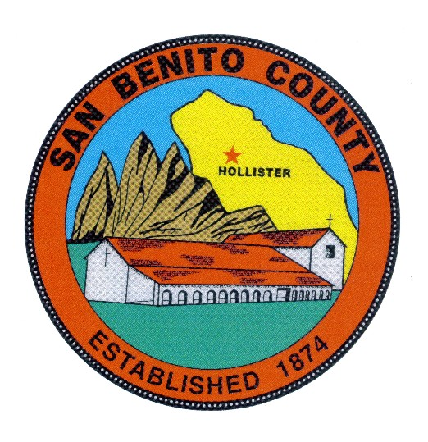
COUNTY OF SAN BENITO, STATE OF CALIFORNIA

BEHAVIORAL HEALTH BOARD

1131 SAN FELIPE ROAD

HOLLISTER, CA 95023

PHONE (831) 636-4020

A G E N D A
Behavioral Health Board Meeting
Date: Thursday, February 20, 2020
Time: 12:00 p.m. to 1:30 p.m.

Place: San Benito County Behavioral Health Department
1131 San Felipe Rd. Hollister, Ca. 95023

Members: Rosa Apodaca, Pat Loe, Sherry Holmquist, Dan Sanidad, Margie Barrios,
BOS Appointee, Supervisor Jim Gillio, Tina Garza, Emanuel Gonzalez

Guest: IDEA Consulting, Dr. Nancy Callahan, Phd.

════════════════════════════════════════════════════

- CALL MEETING TO ORDER

- INTRODUCTIONS

- ROLL CALL

- CERTIFICATE OF POSTING

- MINUTES – ACTION: Review and approve the Behavioral Health Board minutes for January 16, 2020 meeting.

- PUBLIC COMMENT:

- CORRESPONDENCE:
  - Articles available at the meeting for review and copies available on request.

- OLD BUSINESS:
a) None

- CHAIRPERSON REPORT

- BHB Member Trainings Attended

- Esperanza Updates, Youth Center Program Grand Opening

- Behavioral Health Report from the Beh. Hlth Board to the Board of Supervisors, Discuss for Final Approval with IDEA Consulting

- DIRECTOR’S REPORT
  - Standing Item for discussion- Updates on the MHSA Capital Facilities/Tech Component and Behavioral Department Building.

  - Other MHSA issues

  - Updates on Grant Application in partnership with the County Office of Education and other school based services updates

  - State/County Budget Updates, other relevant Behavioral Health budget issues and also Legislative actions and trailer bills with budget implications.

  - DMC-ODS (Drug MediCal-Organized Delivery System) Waiver Project Status Update

- Quality Improvement updates by QI Manager, Events/Issues Report
a) Updates and new issues

- Updates on Substance Abuse Program Activities

- Recruitment/Personnel Updates; MH Clinicians (Ongoing),
QA Mngr.(1 Remaining FTE in recruitment phase), SUDS Counselors (discuss), SUDS Program Manager (updates), Case Managers 2-FTE’s in recruitment,
MH Clinicians (updates)

ADJOURNMENT
To confirm meeting dates and time contact SBCBH (831) 636-4020.
Dates for future meetings are generally scheduled for the (3rd) third Thursday of every month at 12:00 p.m. to 1:30 p.m. No meeting is scheduled for the month of August and the November and December meetings are combined as a holiday potluck luncheon meeting scheduled in December. To confirm meeting dates and times contact SBCBH (831) 636-4020.

ANY MEETING DATE MAY BE SUBJECT TO CHANGE UPON BEHAVIORAL HEALTH BOARD APPROVAL.

