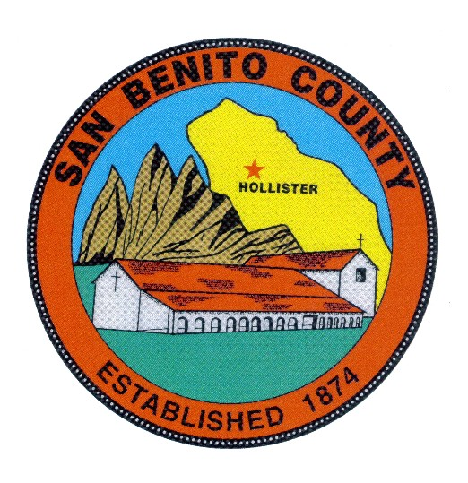
COUNTY OF SAN BENITO, STATE OF CALIFORNIA

BEHAVIORAL HEALTH BOARD

1131 SAN FELIPE ROAD

HOLLISTER, CA 95023

PHONE (831) 636-4020

A G E N D A
Behavioral Health Board Meeting
Date: Tuesday, June 30, 2020
Mental Health Services Act FY 2020/2021-2022/2023 Three Year Plan and Annual Prevention & Early Intervention and Innovation Projects Evaluation Reports
Public Hearing/ Stakeholder Input

Time: 1:00 p.m. to 2:00 p.m.

Place: Behavioral Health Conference Room, 1131 San Felipe Rd.
Hollister, CA 95023

Members: Rosa Apodaca, Pat Loe, Sherry Holmquist, Dan Sanidad, Margie Barrios,
BOS Appointee, Supervisor Jim Gillio, Tina Garza

════════════════════════════════════════════════════

The MHSA FY 3-Year Plan and Evaluation Report has been available for public review and comment from May 28, 2020 through June 26, 2020.

We also welcome comments during the Public Hearing to be held on June 30, 2020.

Public Hearing Information:
Tuesday, June 30, 2020 at 1:00 pm
Special session of the Behavioral Health Board Meeting
Due to COVID-19 restrictions, the meeting will be held online, via Zoom.
Zoom meeting link: https://zoom.us/j/96077357167

If you prefer to join by phone, please call: 1-669-900-6833.
Enter Meeting ID: 960 7735 7167

Feedback or Questions? Please contact Juan Gutierrez-Cervantes
MHSA 3-Year Plan
San Benito County Behavioral Health
1131 San Felipe Road, Hollister, CA 95023
Phone: 831-636-4020; Fax: 831-636-4025
JGutierrez@sbcmh.org
Thank you!

- CALL MEETING TO ORDER

- INTRODUCTIONS

- ROLL CALL

- CERTIFICATE OF POSTING

- MHSA (MH Services Act) Public Hearing for the 3 Year Plan, FY 2020-2021-2022-2023 and the Annual Prevention and Early Intervention and Innovation Projects Evaluation Reports

- PUBLIC COMMENT

ADJOURNMENT
To confirm meeting dates and time contact SBCBH (831) 636-4020.
Dates for future meetings are generally scheduled for the (3rd) third Thursday of every month at 12:00 p.m. to 1:30 p.m. No meeting is scheduled for the month of August and the November and December meetings are combined as a holiday potluck luncheon meeting scheduled in December. To confirm meeting dates and times contact SBCBH (831) 636-4020.

ANY MEETING DATE MAY BE SUBJECT TO CHANGE UPON BEHAVIORAL HEALTH BOARD APPROVAL.

